

















Content Creation & Marketing Copy Generation
Project Domain

AI Chatbot

A Collaborative Initiative

equipping students with practical skills in AI, Data Analytics, and Business
Intelligence

b
y:

Institution
:

N
ational
Post Graduate College

Year
-

2026

Student
Name

Sakshi mishra

Student Email

s
mishrasakshi1
1
@gmail.com

Guide

umamheshwari

Problem Statement

Organizations across industries collect large volumes of data on a daily basis. However, this data is often raw, inconsistent, incomplete, or poorly structured, making it difficult to derive meaningful insights. Decision-makers rely on accurate, clean, and well-visualized data to make informed choices, but without the right tools and skills, this data remains underutilized.
Additionally, the rapid growth of Artificial Intelligence and Generative AI tools such as Microsoft Copilot and AI Chatbots has created both an opportunity and a skills gap. Professionals who can effectively use these tools through well-structured prompts can significantly accelerate their work. However, most users lack the knowledge of prompt engineering techniques needed to unlock the full potential of these AI tools.
This project addresses these challenges by applying data cleaning, analysis, visualization, and AI integration techniques using industry-standard tools. The project will demonstrate how structured data workflows combined with AI assistance can produce accurate, actionable insights and outputs relevant to a chosen real-world domain.
Here are short and clear answers for your four questions based on the project “Content Creation and Marketing Copy Generation Using Effective Prompts.”

- Background of the chosen domain and the data-related challenges it faces ?
Content creation and digital marketing rely heavily on large amounts of text data for advertisements, blogs, emails, and social media posts. However, marketers often struggle with inconsistent messaging, lack of creativity, and time-consuming manual writing.
Managing and generating high-quality content quickly is a major data-related challenge.

- Why this problem is significant in a real-world context ?
Businesses today depend on online marketing to reach customers. If content is not engaging or relevant, it can reduce customer interest and marketing effectiveness. Improving content generation helps companies communicate better with their audience and stay competitive.

- Specific gap or inefficiency the project aims to address ?
Many marketers spend a lot of time creating marketing copy manually and may not always produce optimized or creative content. This project aims to address that gap by using effective prompts to generate structured, high-quality marketing content quickly and consistently.

- Who is affected and what value the solution will deliver ?

Digital marketers, content creators, small businesses, and social media managers are affected by this issue. The solution will help them save time, improve creativity, and generate effective marketing content faster, leading to better audience engagement and productivity.

2. Objectives

List the specific goals your project aims to accomplish. Objectives should be clear and measurable.
- To collect and explore the raw dataset, understand its structure, fields, and data quality issues.
- To clean and preprocess the data by removing duplicates, handling missing values, correcting formats, and standardizing fields.
- To apply domain-relevant analysis using the assigned tool (Excel formulas and pivot tables, Power BI measures, or AI prompt techniques).
- To build an interactive dashboard, structured report, or AI-generated output that communicates insights clearly to stakeholders.
- To integrate AI tools like AI Chatbot to automate, enhance, or accelerate the analysis and content generation process.

3. Methodology / Implementation Plan

Provide a simple overview of how the project will be carried out. The following five-phase workflow applies to all projects under this fellowship program.

# | Phase | Description
1 | Data Collection & Exploration | Obtain the raw dataset (CSV / Excel) from Kaggle, Edunet, or any suitable source. Understand field names, data types, and row count. For AI prompt projects, define the use case and target audience instead.
2 | Data Cleaning & Preprocessing | Remove duplicates, handle null or missing values, fix incorrect data types, and standardize date and text formats using Excel (Remove Duplicates, IF, IFERROR, Text-to-Columns) or Power Query. For prompt-based projects, draft and structure initial prompts using Role, Context, Task, Format, and Tone components.
3 | Analysis & AI Integration | Apply pivot tables, Excel formulas (SUMIF, COUNTIF, VLOOKUP), or Power  BI DAX measures to derive key insights. Where applicable, use Microsoft Copilot or an AI Chatbot to generate narratives, summaries, or content outputs from the data or prompts.
4 | Visualization / Output | Build interactive dashboards with charts, KPI cards, and slicers in Power BI or Excel. For AI-assisted projects, compile generated content outputs such
 |  | as reports, marketing copy, or summaries. Document all AI prompts used alongside their outputs.
5 | Documentation & Submission | Write the project report, upload all files to a GitHub repository, and record a video demonstration. Submit the GitHub link, video link, and dashboard link (if applicable) for evaluation.

4. Resources and Timeline

A. Hardware & Software Requirements

- Laptop or PC — Intel Core i3 or higher, minimum 4 GB RAM (8 GB recommended)
- Operating System: Windows 10 / 11 or macOS
- Microsoft Excel (Microsoft 365 / Excel 2019 or later)
- Power BI Desktop — latest version (free download from Microsoft) — where applicable
- Microsoft Copilot — via Microsoft 365 subscription — where applicable
- AI Chatbot (ChatGPT / Google Gemini / Microsoft Copilot Web) — for prompt-based projects
- Internet connection — required for Copilot and AI Chatbot access
- Web browser — Google Chrome or Microsoft Edge (latest version)

B. Dataset

- Whether the dataset is already available or needs to be sourced
- Source link if publicly available (e.g., Kaggle, UCI Repository, Edunet-provided)
- If not available, how the dataset will be collected, generated, or simulated
- For AI prompt projects: description of the use case brief and reference content used as input

C. Project Timeline

A simple table showing planned tasks and expected completion dates.

Phase | Task | Tentative Completion Date
1 | Dataset collection, exploration, and understanding | Week 1
2 | Data cleaning, preprocessing, and validation / Prompt design | Week 2
3 | Analysis, AI tool integration (Copilot / Chatbot), and insight generation | Week 2 – 3
4 | Dashboard / output build, testing, and review | Week 3
5 | Report writing, GitHub upload, and video recording and submission | Week 4

- 5.What the project is about –

- The project focuses on using AI-driven systems to generate marketing content like ads, emails, and social media posts.
- Goal: faster, consistent, and scalable content creation.

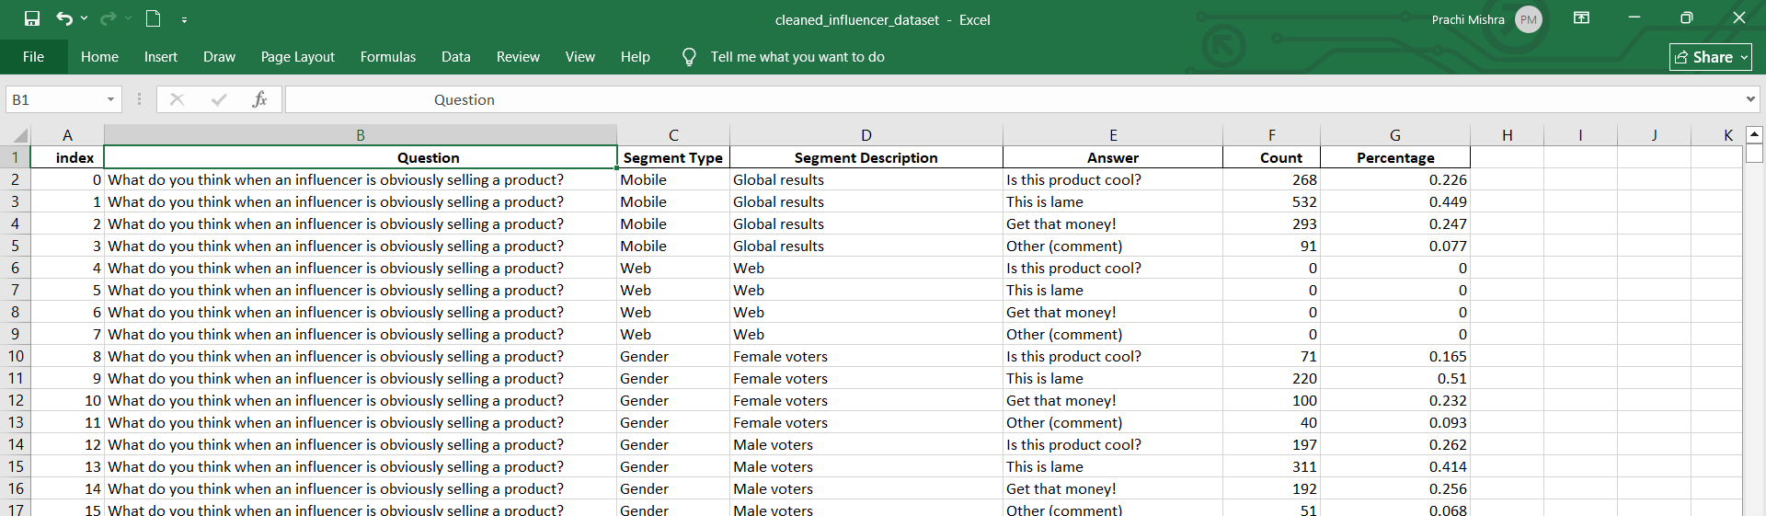

6.Key Insights from the Data

1. Relatable people dominate influence
- “Friends” and “people who do similar things” have higher counts
👉 People trust relatability over fame

2. Authenticity matters more than popularity
- Responses like “they're a leading voice in culture” rank higher than just “famous people”
👉 Audience prefers value-driven influencers

3. Mixed reaction to promotional content
- Many responses show skepticism like:

7. Influencer Insights
The project integrates influencer sentiment analysis to better understand how audiences perceive content and what drives engagement. Instead of relying only on AI-generated text, it uses real audience behavior and opinions to make content more relatable and effective.

🔍 What the Data Shows
The dataset reveals several important audience preferences:
- People are more influenced by friends and relatable individuals rather than just celebrities.
- Influencers who are seen as authentic, culturally relevant, or meaningful have stronger impact.
- Platforms like Instagram and Facebook dominate content consumption.
- Users respond positively to content that feels:
  - Genuine
  - Entertaining (memes, humor)
  - Emotionally or socially relevant
- Some audiences are skeptical of influencer marketing, showing responses like “this is lame” or “no, it’s whatever”, which highlights the need for authenticity.

8. Numerical Data Presentation

🔢 Top Influencer Responses (Sample Data)
Factor / Response | Count
Friends | 28,325
Yes, very much so | 17,028
They’re a leading voice in culture | 16,029
Somewhat | 15,171
Instagram | 11,158
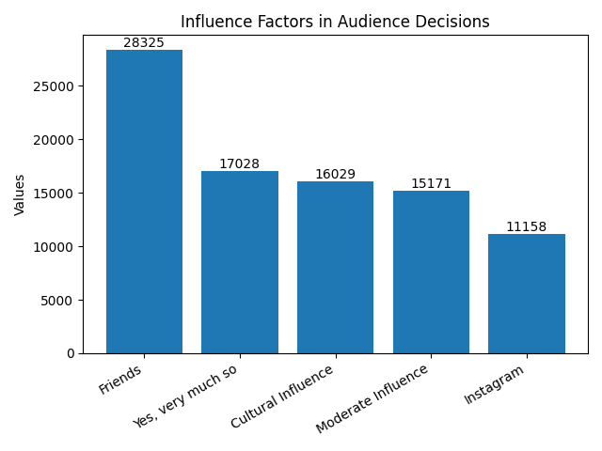
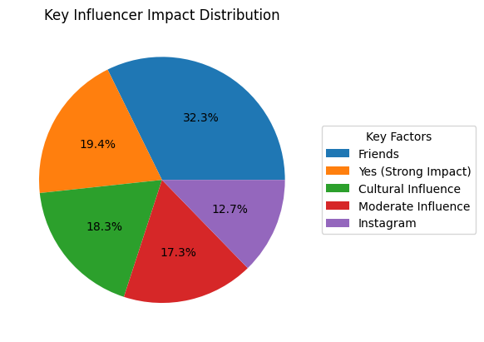

The data shows that friends (28,325) have the highest influence, indicating people trust personal connections the most. A significant number of respondents (17,028) strongly agree that influencers impact their decisions, highlighting the effectiveness of influencer marketing. Cultural influencers (16,029) also play an important role, showing that thought leaders are valued beyond celebrities. However, moderate influence (15,171) suggests that not all users are fully convinced, reflecting mixed perceptions. Among platforms, Instagram (11,158) emerges as the most powerful channel for influencer marketing.

9. Expected Outcomes / Conclusion

This section summarizes what the team expects to deliver by the end of the project. Outcomes should be realistic and directly tied to the objectives stated above.
- A clean, validated dataset with all preprocessing steps documented and a before/after comparison.
- An interactive dashboard or structured analytical report that clearly communicates key insights from the data.
- AI-driven content creation enables fast, scalable, and consistent marketing output while maintaining brand voice.
- Automation using structured prompts improves efficiency, accuracy, and content quality across multiple platforms.
- Data insights show that friends (personal connections) have the highest influence, emphasizing the importance of authenticity in marketing.
- A large number of users believe influencers strongly impact decisions, proving the effectiveness of influencer marketing strategies.
- The presence of moderate influence responses indicates that audiences are selective and not fully convinced by all content.
- Cultural thought leaders are more influential than traditional celebrities, showing a shift toward meaningful and value-driven content.
- Instagram emerges as the most powerful platform, highlighting the need for platform-specific content optimization.
- Combining AI with audience insights enables better personalization, smarter decision-making, and improved engagement.
- Overall, this integrated approach ensures marketing is data-driven, authentic, and aligned with modern audience expectations, leading to better campaign outcomes

10. References

List all references, tutorials, and documentation used in the project. Students must cite any material they referred to, including research papers, GitHub repositories, YouTube tutorials, blogs, and official documentation.
- Edunet Foundation. AICW Fellowship Program Guidelines. 2026. Available at:
https://www.edunetfoundation.org
- LinkedIn Learning. AI and Data Analytics Courses. 2026. Available at: https://www.linkedin.com/learning
- Microsoft Corporation. Microsoft Excel Documentation. Available at:
https://support.microsoft.com/en-us/excel
- Microsoft Corporation. Power BI Documentation. Available at:
https://learn.microsoft.com/en-us/power-bi/
- Microsoft Corporation. Microsoft Copilot. Available at: https://copilot.microsoft.com
- Kaggle Inc. Open Datasets. Available at: https://www.kaggle.com/datasets

Example of AI Prompt and Output
Prompt Used:
Role: You are a professional digital marketer.
Task: Create an Instagram caption for a skincare product.
Tone: Engaging and friendly
Target Audience: Young women (18–30) Format: Short caption with emojis and hashtags.
AI-Generated Output:
Glow like never before Say hello to radiant, healthy skin with our all-new herbal skincare range
Because your skin deserves the best care, every single day.
- #SkincareRoutine #GlowUp #HealthySkin #NaturalBeauty
“This demonstrates how structured prompts improve content quality and efficiency.”

